The Hudson Valley Sciontists

will meet at 6:00 pm on Sunday, October 23, 2016

to dine and discuss The Man with the Twisted Lip

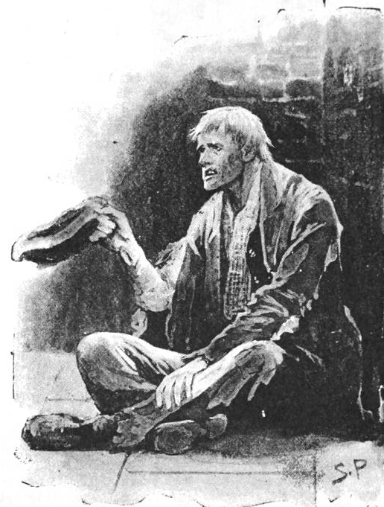

at Vassar College Alumnae House,
Raymond Avenue, Poughkeepsie, NY 12601

RSVP with check ($42 per person) to Lou and Candy Lewis
2 Loockerman Avenue, Poughkeepsie, NY 12601.
Phone: (845) 471-0296. Email: CLewis1880@aol.com

JCR/20016

