The Hudson Valley Sciontists will dine and discuss

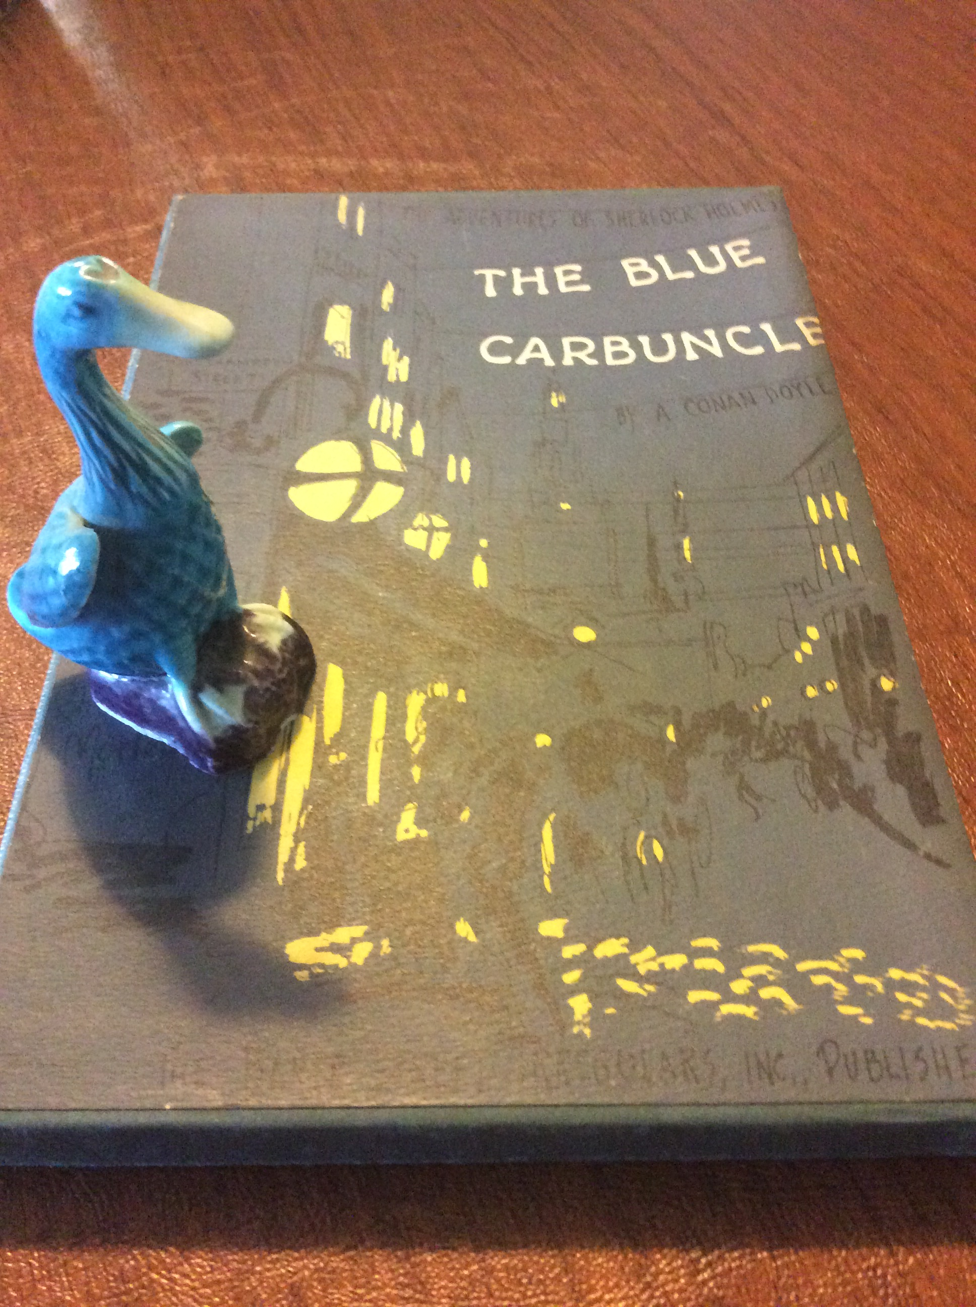

at Vassar College Alumnae House

Sunday, October 29, 2017

6:00 pm cocktails (cash bar), 6:30 dinner

RSVP with check ($42): Lou and Candy Lewis, 2 Loockerman Ave, Poughkeepsie, NY 12601. Phone: (845) 471-0296.
Email: CLewis1880@aol.com

JCR/17

