The Hudson Valley Sciontists

will dine and discuss

The Reigate Squire
∗

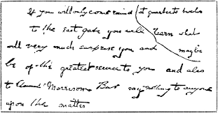

Sunday, May 22, 2016

Vassar College Alumnae House

6:00 p.m. cocktails (cash bar) 6:30 p.m. dinner

RSVP with check ($42):
Lou and Candy Lewis, 2 Loockerman Ave, Poughkeepsie, NY 12601.
Phone: (845) 471-0296.
Email: CLewis1880@aol.com

jcr/16

∗ Also known as “The Reigate Squires” and “The Reigate Problem.”

