The Hudson Valley Sciontists will discuss

The Adventure of the Cardboard Box

Come lend an ear

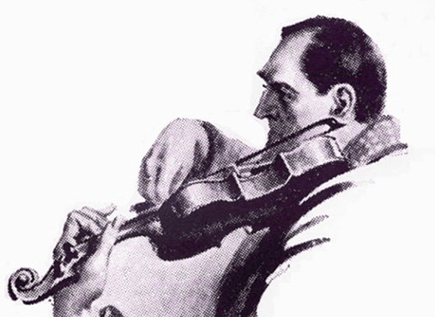

Sunday, October 18, 2015 at Vassar Alumnae House
6:00 p.m. cocktails (cash bar) 6:30 p.m. dinner

RSVP with check ($42):
Lou and Candy Lewis, 2 Loockerman Ave, Poughkeepsie, NY 12601.
Phone: (845) 471-0296.
Email: CLewis1880@aol.com

